COMP6200 - P1

## String Manipulation

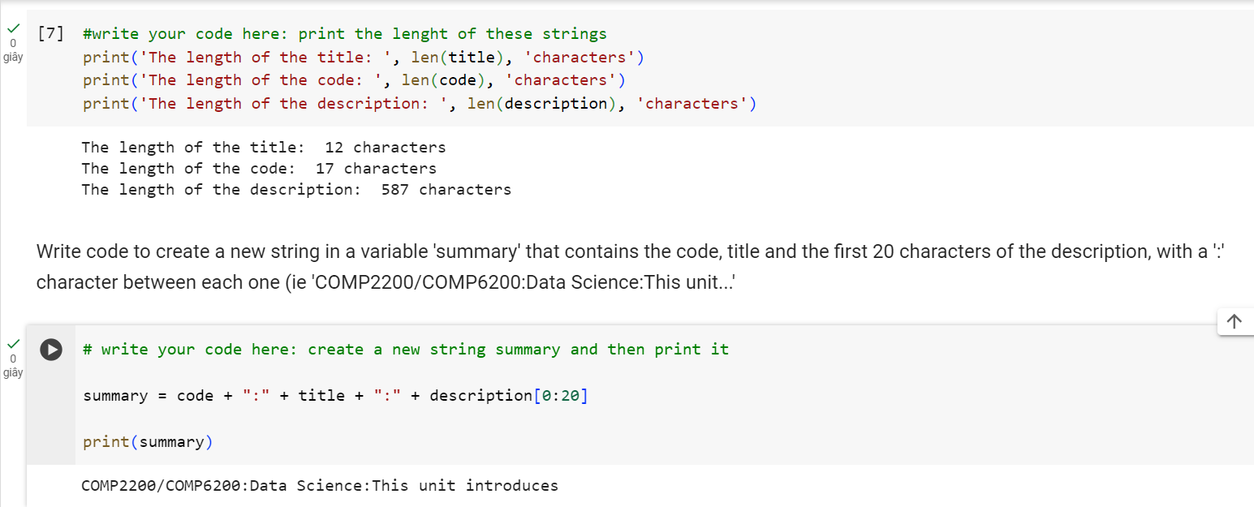

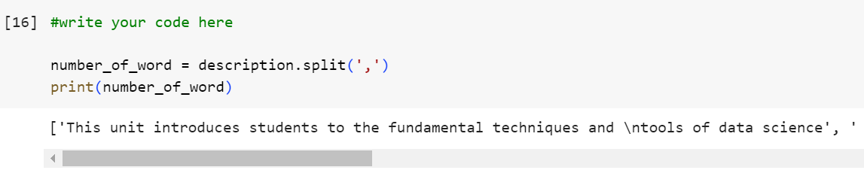

Splitting the paragraph according to where the ‘comma’ appears, for example:

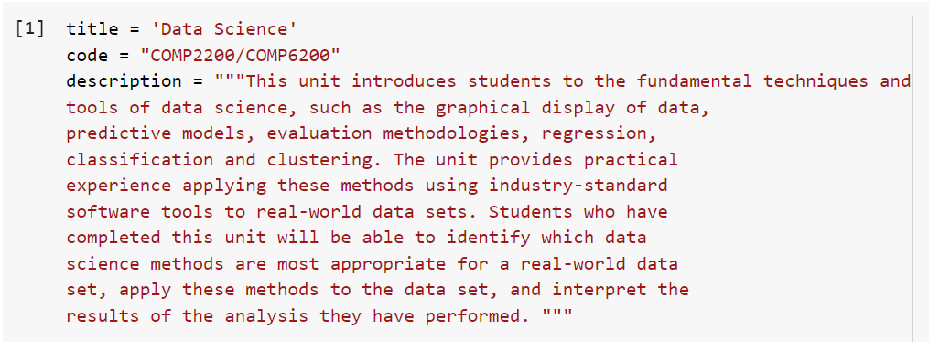

Without ‘comma’ in the ‘’, it will split it word by word:

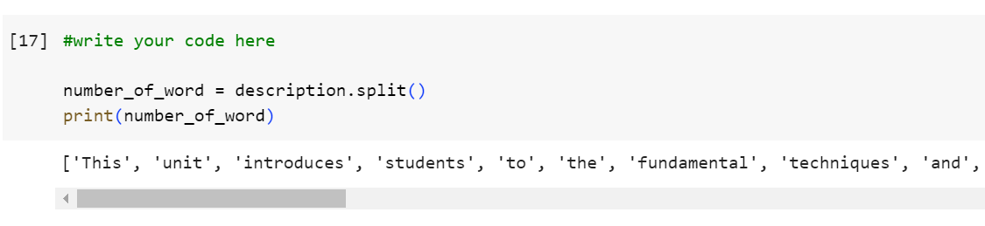

With the ‘len’ function:

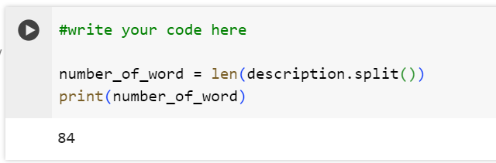

## Control Structures

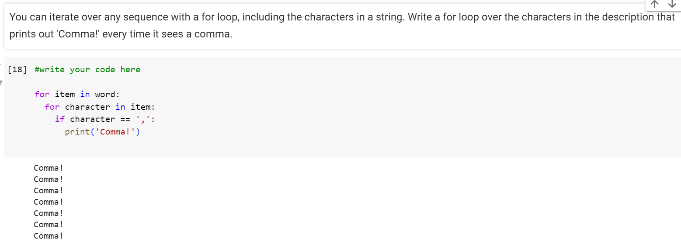

## Functions

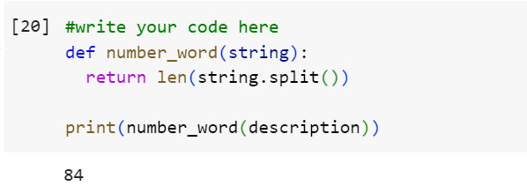

Now, we want to define our own function. For example, here, we want to define a function name ‘number_word’ that can be used to count the number of a specified variable, which is the ‘len’ function. So here to define a function we have the name, return.

## Data and Plotting

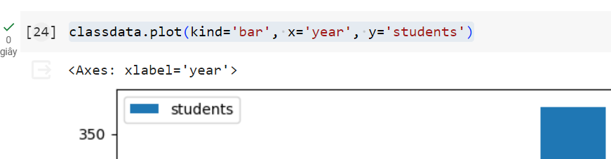

<https://pandas.pydata.org/pandas-docs/stable/user_guide/visualization.html>

Add a new variable

